Connecting PYTHON and NETEZZA

Step 1: install pyodbc

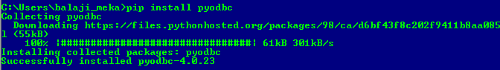

Step2: Install netezza ODBC and add it in system DSN

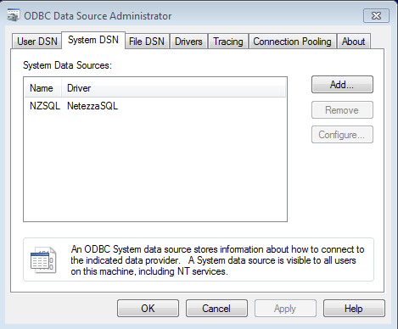

(https://www.ibm.com/support/knowledgecenter/en/SSZJPZ_8.7.0/com.ibm.swg.im.iis.conn.netezza.use.doc/topics/creating_datasource_windows_nzcc.html)

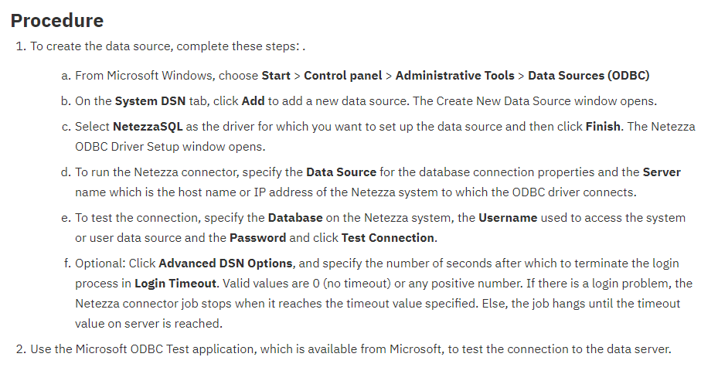

Step3: Testing connection

import pyodbc

print (pyodbc.dataSources())



